**ER model**

**Entities, Attributes and Primary Keys:**

Restaurant (**restId**,restName, restLocation,-street, -district, restAvgPrice, restParking,restOpenPeriod ,restClosingDay, restVeggie, restDeliver,restPhone)

Cuisine (**cuiId**, cuiName)

Payment (**payId**, payName)

Customer (**cstId**, cstName)

App (**appId**, appName)

**Relationships, Attributes, Degrees, Participating Entities and Constraints:**

Offer: binary relationship

1 Restaurant to 1 or more Cuisines

1 Cuisine to 0 or more Restaurants

Register(restRate): binary relationship

1 Restaurant to 1 or more Apps

1 App to 1 or more Restaurants

Review (rvwDate, rvwRate, rvwComments): ternary relationship

1 Customer and 1 App to 0 or more Restaurants

1 App and 1 Restaurant to 0 or more Customers

1 Restaurant and 1 Customer to 1 or more Apps

Accept: binary relationship

1 Restaurant to 1 or more Payments

1 Payment to 0 or more Restaurants

**Finalized ER diagram**

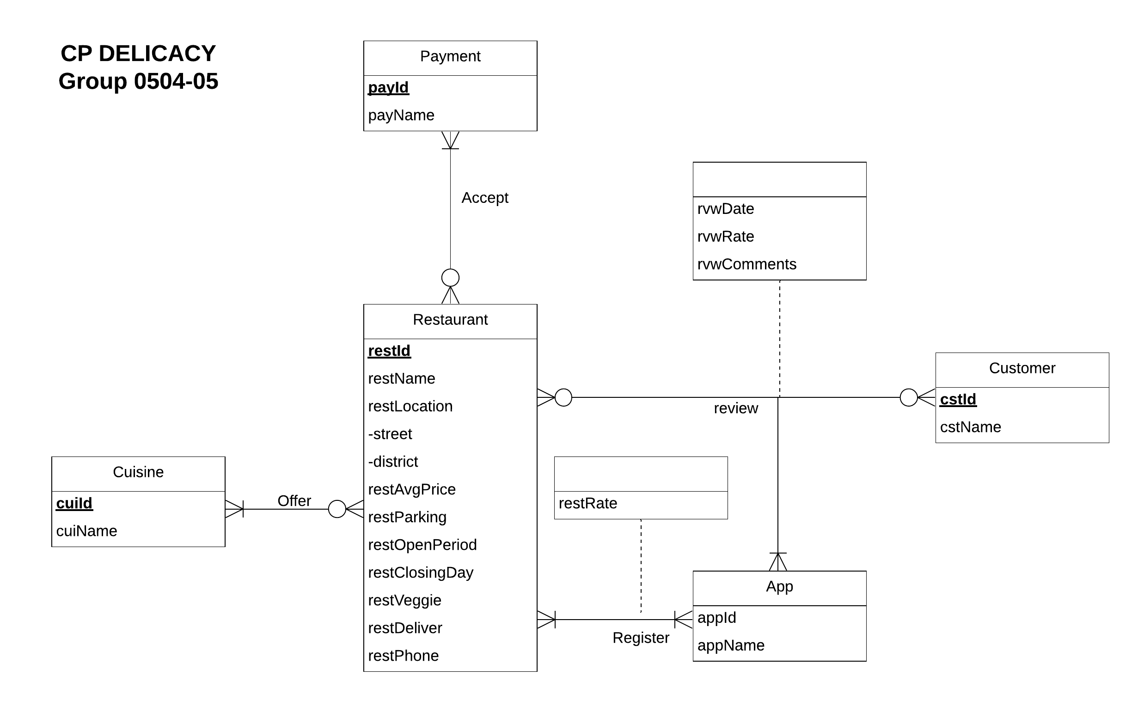

**Relational schema:**

**Relations:**

Restaurant (**restId**, restName, street, district, restAvgPrice, restParking, restOpenPeriod, restClosingDay, restVeggie, restDeliver, restPhone)

Cuisine(**cuiId**, cuiName)

Payment(**payId**, payName)

Customer(**cstId**, cstName)

App(**appId**, appName)

Offer (***restId****,* ***cuiId***)

Register(***restId***, ***appId***, restRate)

Review (***restId****,* ***appId****,* ***cstId***, rvwDate, rvwRate, rvwComments)

Accept(***restId***,***payId***)

**Function dependency:**

restId ->restName, street,district, restAvgPrice, restParking, restOpenPeriod, restClosingDay, restVeggie, restDeliver, restPhone

cuiId -> cuiName

payId -> payName

cstId -> cstName

appId -> appName

restId, cuiId ->

restId, appId -> restRate

restId, appId, cstId -> rvwDate, rvwRate, rvwComments

restId, payId ->

**Normalization (3NF):**

Restaurant (**restId**,restName, street, district, restAvgPrice, restParking, restOpenPeriod, restClosingDay, restVeggie, restDeliver, restPhone)=3NF

Cuisine(**cuiId**, cuiName)=3NF

Payment(**payId**, payName)=3NF

Customer(**cstId**, cstName)=3NF

App(**appId**, appName)=3NF

Offer (***restId****,* ***cuiId***)=3NF

Register(***restId***, ***appId***, restRate)=3NF

Review (***restId****,* ***appId****,* ***cstId***, rvwDate, rvwRate, rvwComments)=3NF

Accept(***restId***,***payId***) =3NF

**Business rules:**

[R1] When a restaurant is deleted from the database, the corresponding information should be deleted.

[R2] When a restaurant is changed from the database, the corresponding information should be changed

[R3] When a cuisine is deleted from the database, the corresponding information should be deleted.

[R4] When a cuisine’s information is changed in the database, the corresponding information should be changed.

[R5] When a restaurant information is changed from the database, the payment information should be changed.

[R6] When a restaurant is deleted from the database, the payment should be deleted accordingly.

[R7] When a payment method is deleted from the database, the payment information should be deleted.

[R8] When a payment method is changed in the database, the payment information should be changed correspondingly.

[R9] When a restaurant’s information is deleted in the database, the review information should be deleted.

[R10] When a restaurant’s information is changed in the database, the review information should be changed.

[R11] When an app’s information is deleted in the database, there should be no action about the corresponding review information.

[R12] When an app’s information is changed in the database, the corresponding review information should be updated.

[R13] When a customer is reviewing a restaurant in an app, the review information should not be deleted or changed.

[R14] When a restaurant is deleted from the database, the registration corresponding information should be deleted.

[R15] When a restaurant’s information is changed in the database, the registration corresponding information should be changed.

[R16] When an app deleted from the database, the registration information should be deleted.

[R17] When an app’s information is changed in the database, the registration information should be changed correspondingly.

**Referential integrity action:**

|  |  |  |  |  |  |  |  |
| --- | --- | --- | --- | --- | --- | --- | --- |
| Relation | Foreign Key | Base Relation | Primary Key | Business Rule | Constraint: ON DELETE | Business Rule | Constraint: ON UPDATE |
| Offer | restId | Restaurant | restId | R1 | CASCADE | R2 | CASCADE |
| Offer | cuiId | Cuisine | cuiId | R3 | CASCADE | R4 | CASCADE |
| Accept | restId | Restaurant | restId | R6 | CASCADE | R5 | CASCADE |
| Accept | payId | Payment | payId | R7 | CASCADE | R8 | CASCADE |
| Review | restId | Restaurant | restId | R9 | CASCADE | R10 | CASCADE |
| Review | appId | App | appId | R11 | NO ACTION | R12 | CASCADE |
| Review | cstId | Customer | cstId | R13 | NO ACTION | R13 | NO ACTION |
| Register | restId | Restaurant | restId | R14 | CASCADE | R15 | CASCADE |
| Register | appId | App | appId | R16 | CASCADE | R17 | CASCADE |

**Describe sample data for every relation**

Restaurant (**restId**,restName, street, district, restAvgPrice, restParking, restOpenPeriod, restClosingDay, restVeggie, restDeliver, restPhone): A sample data for this relation would be ‘000001’, ‘Pho D Lite, ‘8147 Baltimore Ave’, ‘College Park’,‘ $’, ‘Yes’, ‘10:30-21:30’, ‘None’, ‘Yes’, ‘Yes’,’ 3019825599’.

Cuisine(**cuiId**, cuiName): A sample data for this relation would be ‘000001’, ‘American’.

Payment(**payId**, payName): A sample data for this relation would be ‘00001’, ‘creditCard’.

Customer(**cstId**, cstName): A sample data for this relation would be ‘c001’, ‘Josue Castillo’.

App(**appId**, appName): A sample data for this relation would be ‘00001’, ‘GoogleMaps’.

Offer (***restId****,* ***cuiId***): A sample data for this relation would be ‘000003’, ‘000001’.

Register(***restId***, ***appId****,* restRate): A sample data for this relation would be ‘000001’, ‘00001’, ‘3.8’.

Review (***restId****,* ***appId****,* ***cstId***, rvwDate, rvwRate, rvwComments): A sample data for this relation would be ‘000001’, ‘00001’, ‘c001’, ‘10/12/2019’, ‘5’, ‘I liked it.Seem like teens first job but have No complaints I had my first job once and I m willing to give people the chance to learn because I was in the exact same shoes once.Great job!’.

Accept(***restId***,***payId***): A sample data for this relation would be ‘000001’, ‘00001’.